Betty H Fairfax AVID  8225 S 59th Ave  Laveen, AZ, 85339  E-Mail: aslaughter@phoenixunion.org  Web: MrsSeals.weebly.com | 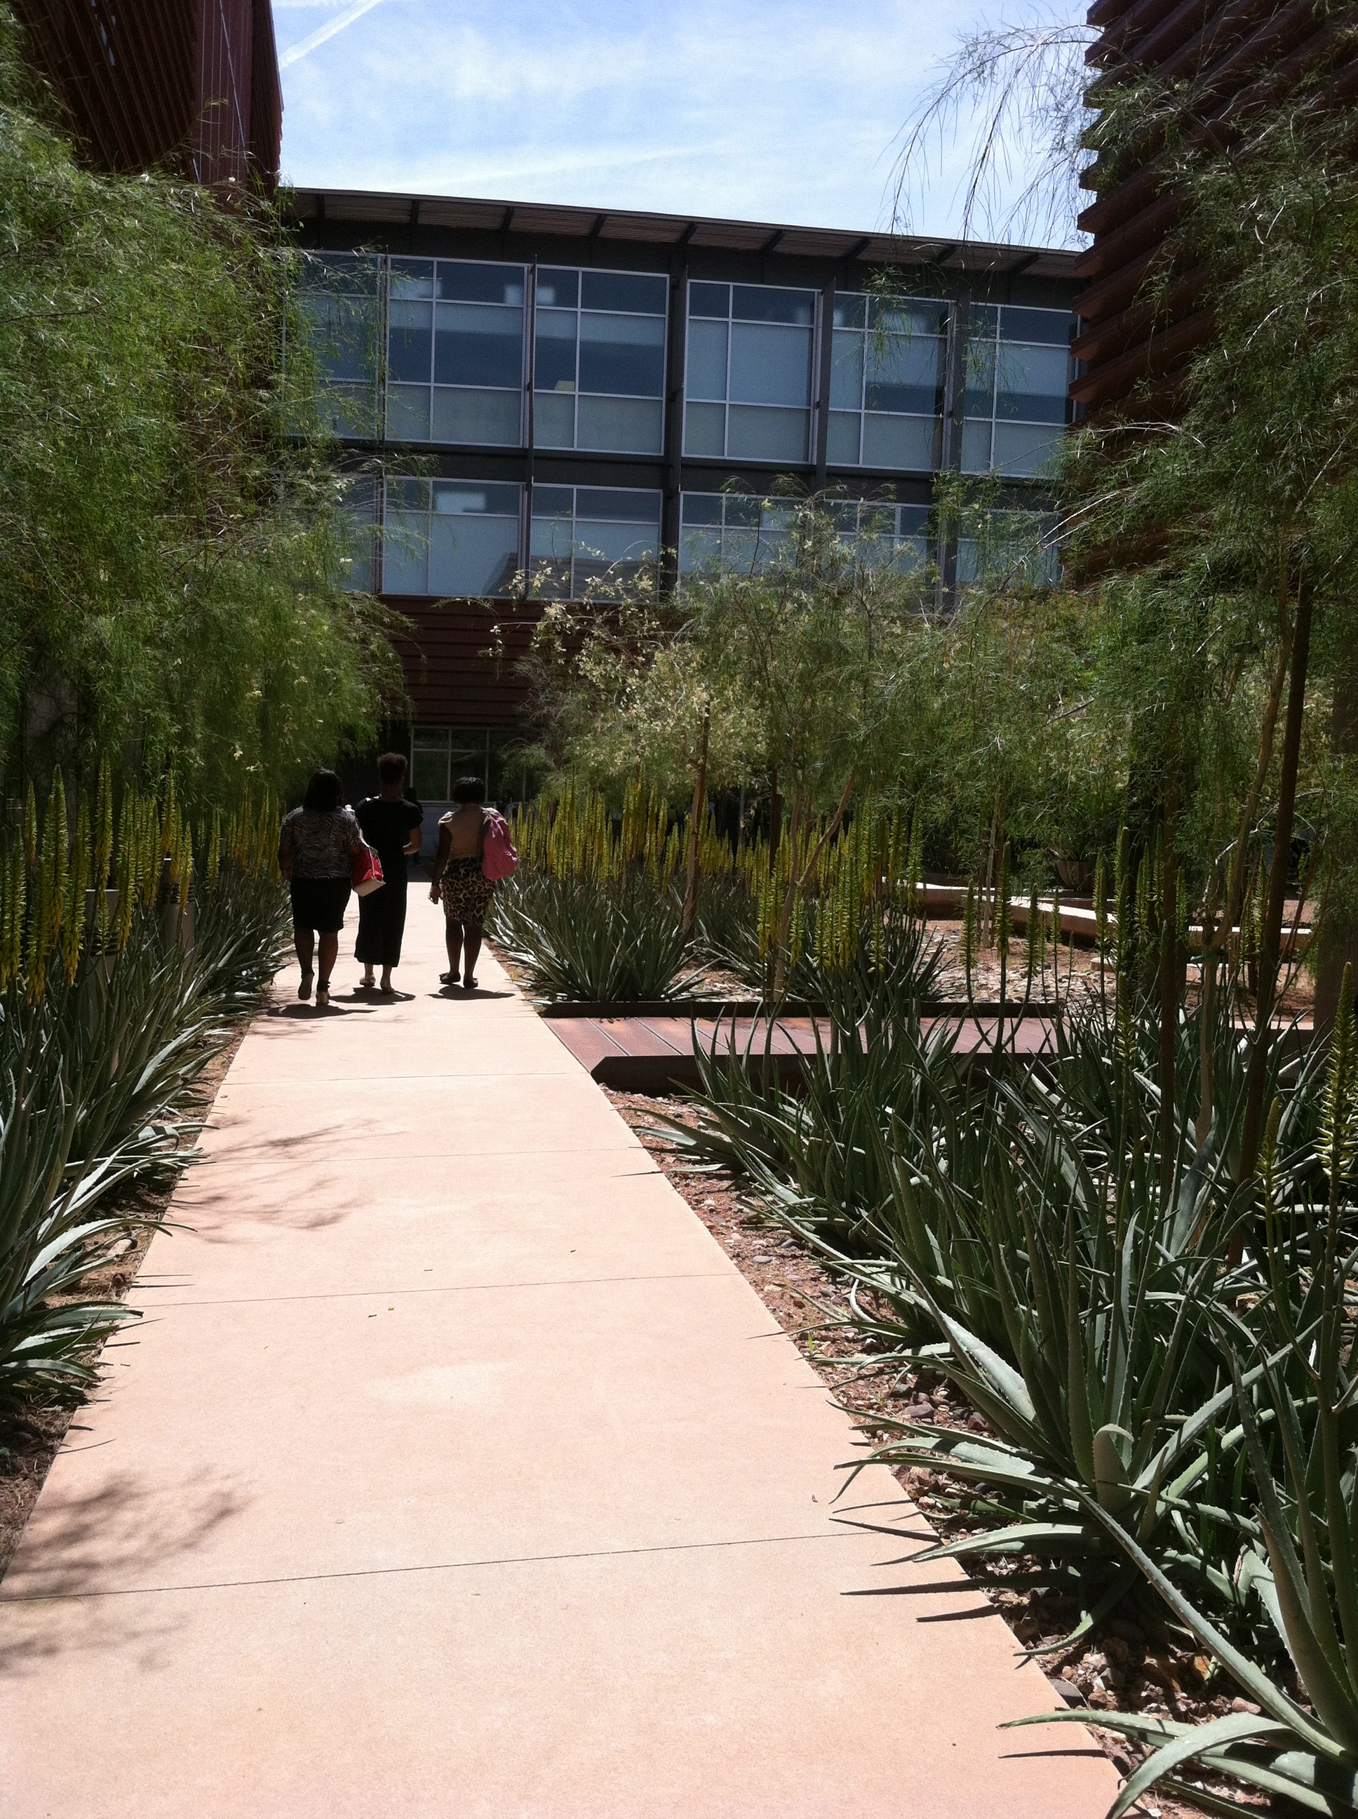

May 2014 | bfhs | virtual field trips  Senior AVID project

VIRTUAL FIELD TRIPS
As graduating Senior you have been charged with leaving a sustaining legacy. Your task is to create a virtual field trip for our future students. Students from all over he Laveen community, South Valley, and even state of Arizona will be invited to explore all areas of our state of the art campus with your narration. By the conclusion of their virtual experience they will be beyond impressed and determined to enroll here at Betty H Fairfax High School where we rest at the foot of the stars (Estrella Mountains). The Fairfax webpage will have navigation buttons below for visitors to choose an area of interest on which to take a virtual tour!

REQUIREMENTS & DETAILS
Your Final project must be submitted through www.turnitin.com on OR before Friday May 9, 2014 by 5:00pm. You can choose between a google docs presentation, prezi, power point, vimeo, youtube or several vine videos. You will be assigned a day to present your Final Virtual Tour the week of May 12-16th. If you are absent on your scheduled day – you must sign-up in tutor-trac to present during tutoring and be graded by my Advisory class before 5/16/14. Please review the Rubric posted below to familiarize yourself with the expectations and objectives. Your Virtual Tour must include the following elements:
- NAME OF TEACHER/PERSON OF INTEREST & LOCATION OF VIRTUAL TOUR
- NARRATION ALONG TOUR OR INTERVIEW OF ‘PERSON OF INTEREST’
- RULES/EXPECTATIONS/PROCEEDURES SPECIFIC TO LOCATION
- LITTLE KNOWN FACTS OR TIPS SPECIFIC TO LOCATION
- PERSONAL RELFECTION OF EXPERIENCE RELATED TO LOCATION

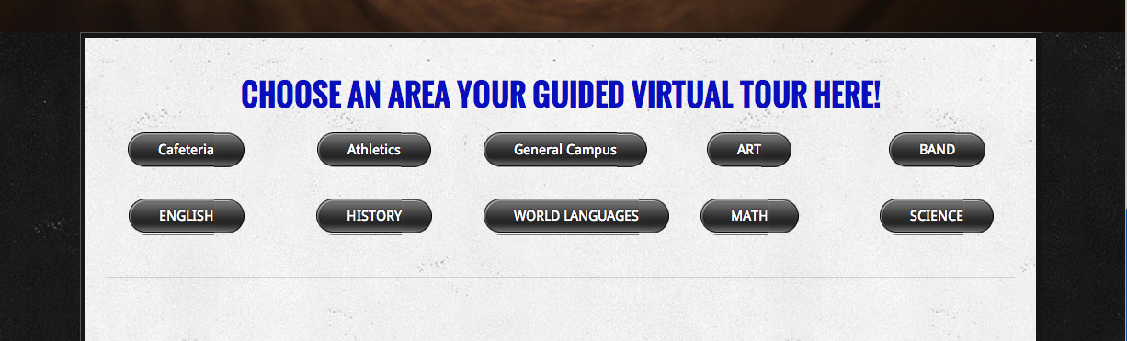

RUBRIC & GRADING DETAILS
 | CATEGORY | 5 | 4 |  | 3 | 2 | SCORE
 | Presentation | Well-rehearsed with smooth delivery that holds audience attention. | Rehearsed with fairly smooth delivery that holds audience attention most of the time. |  | Delivery not smooth, but able to maintain interest of the audience most of the time. | Delivery not smooth and audience attention often lost.
 | Sources | Source information collected for all graphics, facts and quotes. All documented in desired format. | Source information collected for all graphics, facts and quotes. Most documented in desired format. |  | Source information collected for graphics, facts and quotes, but not documented in desired format. | Very little or no source information was collected.
 | Attractiveness | Makes excellent use of font, color, graphics, effects, etc. to enhance the presentation. | Makes good use of font, color, graphics, effects, etc. to enhance to presentation. |  | Makes use of font, color, graphics, effects, etc. but occasionally these detract from the presentation content. | Use of font, color, graphics, effects etc. but these often distract from the presentation content.
 | Requirements | All 5 requirements are met OR exceeded. | 4 requirements are completed. |  | 2-3 requirements were completed. | 1 or 2 requirements were completed.
 | Mechanics of Reflection | No misspellings or grammatical errors. | Three or fewer misspellings and/or mechanical errors. |  | Four misspellings and/or grammatical errors. | More than 4 errors in spelling or grammar.
 | Content | Covers topic in-depth with details and examples. Subject knowledge is excellent. | Includes essential knowledge about the topic. Subject knowledge appears to be good. |  | Includes essential information about the topic but there are 1-2 factual errors. | Content is minimal OR there are several factual errors.
 | Organization | Content is well organized using headings or bulleted lists to group related material. | Uses headings or bulleted lists to organize, but the overall organization of topics appears flawed. |  | Content is logically organized for the most part. | There was no clear or logical organizational structure, just lots of facts.
 | Originality & Creativity | Product shows a large amount of original thought. Ideas are creative and inventive. | Product shows some original thought. Work shows new ideas and insights. |  | Uses other people's ideas (giving them credit), but there is little evidence of original thinking. | Uses other people's ideas, but does not give them credit.
 | Punctuality | Assignment Completed and Submitted on Time | Assignment submitted on time 80-99% complete. |  | Assignment Late and/or 50-79% complete. | Assignment Late and/or 25-49% complete.
 | TOTAL SCORE

