FUNDING THE CALIFORNIA COLLEGE TOUR
Arizona education tax credit
Since many activities are not fully funded by school districts. These programs depend on fees from students, booster clubs and fundraising to pay for student activity fees, costumes, equipment, insurance, competition fees, camps and travel.
The Arizona Education Tax Credit allows single taxpayers or a head of household a credit of up to $200, and married couples filing jointly, up to $400, if they contribute to eligible extracurricular activities to our schools by December 31 of each year. You'll receive a dollar-for dollar tax credit on your state income taxes, which means taxpayers will have the amount of the contribution subtracted from the amount of taxes owed. This tax credit is available to all taxpayers, not just those with children in public schools. This program has benefited thousands of our Phoenix Union students over the years that might not otherwise have had the financial resources to participate in high school activities. It’s a win-win. You contribute to public schools and make a real difference in the lives of young people, and the state gives you full credit for your generosity. Guaranteed!
How to Make a Donation
- To submit your contribution online through PayPal goto: http://phoenixunion.schoolwires.net//site/Default.aspx?PageID=306/
- Select Betty H Fairfax High School and program AVID. If you don’t designate a program, your contribution will be applied to the school’s general fund for extracurricular programs.

- To submit your contribution by mail, address envelope to:
Betty H Fairfax High School
8225 S 59th Ave. Laveen, AZ 85339
Attn: Jaime Duncan, Bookstore
- Be sure to indicate your student’s name and ID# to ensure proper credit.

- To submit your contributions in person visit the school bookstore between 7:15am – 3:15pm and make payment in your student’s name and ID# to ensure proper credit for AVID California College Tour.

FUNRAISING
STAMPEDE Slides and Flip-Flops $20-25/pair being sold thru March 2014
STAMPEDE Pennants - $5.00 being sold at all School and Athletic Events as well as on campus during lunch periods
SPRING TALENT SHOW - Feb 21, 2014
FLOWER SALES Feb 14, 2014

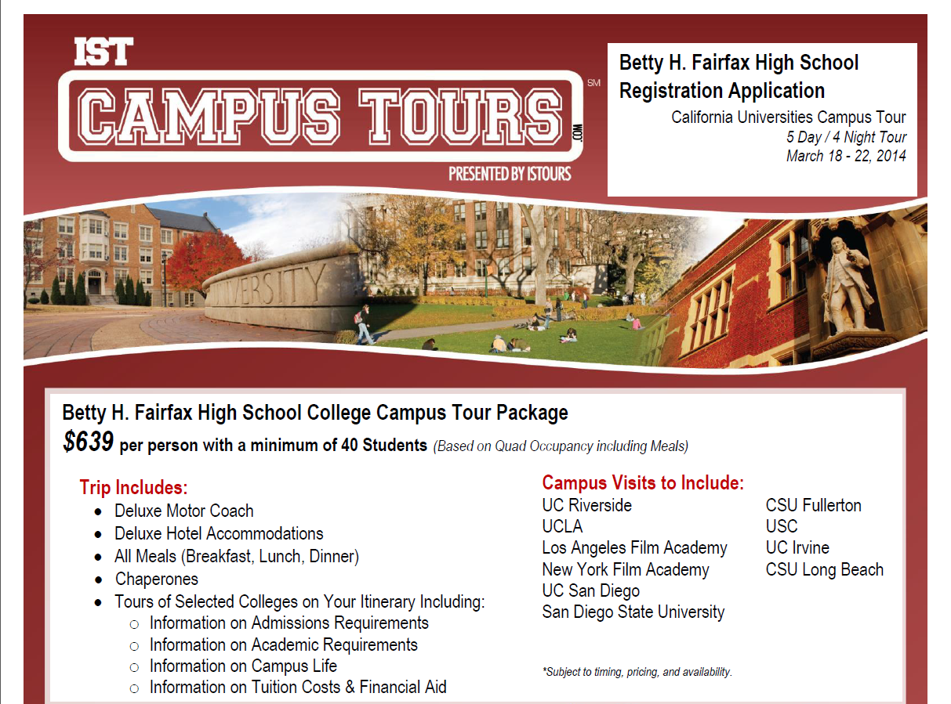

Mandatory Participant/Parent Meeting
Wednesday January 15, 2014
4:30 – 5:00pm
Lobby BIG Gym

Non-Refundable Deposit of $150 due 1/17/14

