 | Step 2:  ACT Registration | https://services.actstudent.org/OA_HTML/actibeCAcdLogin.jsp
 | 1. Fall 2014 ACT Test Dates
 | 2. List 4 things you can do manage with your ACT Account
 | 3.List 3 calculators allowed for the ACT and 1 not-allowed
 | 4.Name the college Readiness Standards | a. |  |  |  | b.
 | c. | d. |  |  |  | e.
 | 5. How long is each test? | English: |  | Math: |  | Science: |  | Reading:
 | 6.What is the cost to send additional scores by mail
 | 7. What is the cost to send additional scores if you phone in?
 | 8.What are the types of financial aid available? | a. |  | b. |  | c. |  | d.
 |  | e. |  | f. |  | g. |  | h.
 | 9. Choose one and explain how you qualify for that aid type?
 | 10. What MUST you apply for in order to receive any type of aid?
 | Step 3:Free Rice | http://freerice.com
 | What is your score at the end of 15 minutes? What category did you choose?
 | How many classmates are registered?
 | What is Mrs. Seals’ score?
 | ACT practice essay #1 | I | O | V | WC | SF | TOTAL
 | ACT practice essay #2 | I | O | V | WC | SF | TOTAL

Step 5:

ACT Practice Essay #1 Rubric
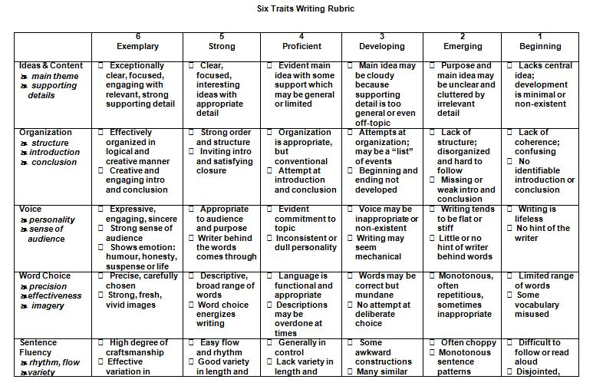
Read Essay #1, then read Column labeled ‘6 Exemplary” for each trait. This is what it takes to get a perfect score. Reread Essay #1 using the rubric below to grade Essay #1. Record your Total score on page 1 of your record sheet.

Step 6:

ACT Practice Essay #2 Rubric
Read Essay #2, then read Column labeled ‘6 Exemplary” for each trait. This is what it takes to get a perfect score. Reread Essay #2 using the rubric below to grade Essay #2. Record your Total score on page 1 of your record sheet.

 | TOPIC/OBJECTIVE: | NAME:
 |  | DATE: PER:
ESSENTIAL QUESTION:
QUESTIONS: | NOTES:
SUMMARY:
STEP 7: www.fairfax.laurusmath.com

